**AIM**:

To analyze a given piece of land for its distribution of plant life using Quadrat Sampling Method.

**THEORY**:

If we want to know what kind and types of plants/animals populate a particular habitat, one can sample the area of interest assuming it is a representative of the entire region.

The most frequently used sampling method is the Quadrat Method.

Quadrat sampling is based on the measurement of replicated sample units referred to as quadrats or plots. This method is appropriate for estimating the abundance of plants and other organisms that are sufficiently sedentary that we can usually sample plots faster than individuals move between the plots. This allows us to measure absolute densities.

***To remove any bias :***

An estimate would be biased if it consistently under-estimates or over-estimates the mean of the area.

Bias may arise by selection of sample plots which are non-random with respect to the target organism. A random sample is the one where every potential sample plot within the study area has an exactly equal chance of being chosen for sampling.

***To increase precision:***

More the area sampled, more is the precision but this comes at the cost of more effort involved in sampling.

***Statistical description of the population:***

1. Average density – to find the average number of individuals per plot. Add up all the numbers of each species
2. Variance to Mean Ratio - The test is founded on the property of the Poisson distribution that

its mean equals its variance. If the plant species is *randomly* distributed, then the ratio is expected to be one. If the nature of distribution is *clustered,* the variance is expected to be higher than the mean while for a *uniform* distribution, variance is expected to be lower than the mean. Thus, the ratio of variance to mean will be greater than one for clustered while less than one for uniform.

1. T-test – one tailed t-test for independent samples of two different species.

**MATERIALS:**

A metre stick, a plastic ball, a rope and a record notebook.

**PROCEDURE:**

1. Stood at a place inside the area chosen. Chose a spot *randomly.*

In order to choose a spot randomly, a person was made to stand with his/her eyes closed and asked to rotate. Another person completely unaware of this person’s position was asked to stop him/her. The person then stopped and threw the ball wherever he wished to.

This procedure is random since both the person’s involved are not aware of their positions with respect to the piece of land to be sampled.

1. The metre ( ~1.25 m long) stick’s center was kept at the position where the ball landed.
2. Keeping the stick as the diagonal, a square was marked by the rope.
3. Each species of plant found in the first few quadrats was labelled and their numbers counted in each quadrat.
4. Average densities were calculated, their kind of distribution inferred (whether it was random/clumped/uniform) and a t-test carried out.
5. Standard error was calculated for the variance to mean ratio.

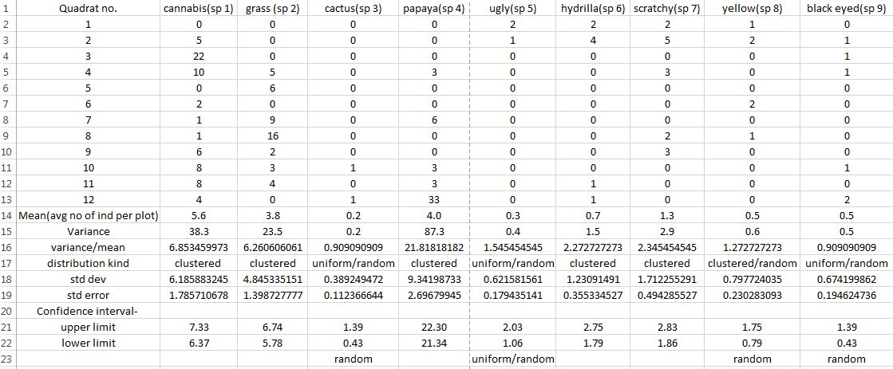**DATA:**

*Note: The names mentioned are just for labelling different species of plants noted, and are not accurate.*

**OBSERVATIONS:**

Data for nine species of plants was collected across twelve quadrats. The land area sampled was the bank of the Nala ( small stream), behind the Faculty Housing.

Mean and variance was calculated for each species of plant.

By looking at the variance to mean ratio, one could easily point out whether the distribution is clustered ( >1 ), random ( =1 ) or uniform ( <1 ).

However, the conclusions drawn might be misleading since the quantities might not be statistically different and may just be a consequence of experimental error.

To eliminate this possibility, t- test was carried out wherein standard error was calculated.

Null Hypothesis: The distribution of species 3, 5, 8 and 9 is random.

Upon calculation of standard error, one could see that the value of the variance to mean ratio could not be very different from 1. Therefore, within experimental limits, species 3, 8 and 9 are randomly distributed. While for species 5, the interval does not overlap with 1, therefore distribution of species 5 is uniform and not random.

Distribution of other species is fairly clear, since the numbers clearly fall under the three different categories and the calculated confidence intervals depict the errors involved.

**CONCLUSION:**

For the chosen land area near the Nala, nine species were sampled using the Quadrat Sampling Method. Their distributions were predicted based on this sampling, and the statistical errors estimated.